Learning at Home – Maths Department

BGE
In BGE formal homework varies in frequency and quantity at the discretion of the class teacher. There is no expectation that formal homework is issued, with some teachers preferring to direct pupils to the revision materials shared on GLOW.
Pupils are encouraged to engage in regular consolidation at home, particularly in the build-up to class assessments. As mentioned above, our revision materials are shared on GLOW with paper copies issued on request if a pupil is unable to access these online.
The revision exercises tie in with the Learning Intentions shared in class and with the headings from our Pupil Learning Logs which, as of August 2017, all S1 pupils are issued with. Solutions are available for these revision exercises in most cases.
Illustrations from our Pupil Learning Logs are given in Appendices 1 and 2.
National 5 and Higher
At National 5 and Higher level, pupils are issued with a number of resources to support learning at home. These resources are comprehensive and, if used as directed, should negate the need for pupils to require further materials.
All pupils require is a quiet space at home where they can sit and engage with the materials provided. This should be done at regular intervals – as a guide, National 5 pupils should spend at least 1-2 hours a week on private study while for Higher this should be increased to at least 2-3 hours.
Resources: Examples Booklets
These cover all of the key skills and concepts for each
topic in the course. The examples need to be worked through
and not just skimmed through. A good strategy would be to
read through the examples from a topic before covering
the solutions up and trying them unaided. Pupils may also
have additional examples given by their class teacher.
Resources: Consolidating Learning Booklets and Solution Booklets
These booklets are made up from past exam questions, organised
by topic, from the last 20 years or so and come with full worked
solutions. Once pupils have worked through the examples booklet
for a topic as suggested above, they should then look to complete
every question, initially using the solutions if unsure, before aiming
to be able to complete them unaided. Pupils should start to notice
the types of questions that are asked repeatedly.
Resources: Self-Assessment Checklists
These give pupils a quick overview of each topic by listing the key skills/concepts which need to be learned. Pupils should read through these, using traffic-lights to identify which areas they are confident with and which areas require further revision. The headings largely match
the Learning Intentions from the course notes, making it easy for pupils to find examples if requiring support.
Further explanation of how these should be used is given in Appendix 3.

Homework: Expectations
Homework is not to be treated as a test but rather as a learning opportunity. If pupils only complete the questions they can do already then what are they actually learning?!
Pupils are given a week to complete each homework so that they have the time to consult their notes, the Consolidating Learning booklets, their peers and/or teacher to get the help that is required. We expect every question to be fully attempted and to a standard that reflects their best work. If a pupil can’t do a question then we expect them to learn how to do it.
If pupils fail to hand in a homework or hand in a piece of work which we feel is below what they are capable of then, apart from in exceptional circumstances, a letter will be issued to share our concerns with home. If, during the same school term, we have further issues with homework then a second letter will be sent home. After that point, however, we will continue to issue homework and encourage pupils to engage with the benefits but will not communicate failure to do so with home.

Homework: Self-Evaluation Sheets (N5 only)
For National 5 pupils, each homework is self-assessed in class and pupils are encouraged to use the self-evaluation checklists provided. These contain guidance on where pupils will find video explanations and further questions to practise.
General Points
- Pupils always have work available to be completed at home, whether it is formal homework or revision using the resources mentioned above. The expectation is that pupils should spend 2-3 hours per week at home revising for Maths. Unlike in other subjects there are no assignments, folios etc to provide a safety net - we are 100% exam based. There are hundreds of concepts to learn over the course of the year – in order for pupils to transfer these concepts to their long term memory they need to be revisited on a regular basis.
- Pupils should look to read ahead in the example booklets and try to make sense of the examples that will be covered by the teacher the following day. This means that when the class teacher goes through the same examples, pupils should be strengthening their understanding of the concepts rather than starting from scratch.
- Pupils need to be careful that they don’t become complacent because they’re doing well compared to their friends – they are in a National Competition! As such, they should not be judging themselves against their peers in Laurencekirk but against the National standard.

Appendix 1: BGE Learning Log - Advice for Effective Use.
WHAT IS THE PURPOSE OF THIS CHECKLIST?

This checklist is designed to help you prepare for assessments as well as charting your progress through the S1 and S2 BGE Maths Course.

It is your own record of progress – you are to decide whether or not you are secure with a particular skill. Some guidance on how to use the checklist is given below.
While we as teachers need to know your strengths and weaknesses, it is equally important, if not more so, that you know your own strengths and weaknesses. This checklist will give both the teacher and pupil useful information if used properly.

You should recognise the ‘Learning Intentions’ – these should match up with the notes you have taken in class, along with the revision materials on GLOW where every skill you have learned is marked clearly with the phrase,
We must be able to …

USING THIS CHECKLIST
- Try each of the questions in your class jotter
- Check your answers (your teacher will go over the solutions with you in class)
- Use this info, along with your general feelings about each skill, to initially traffic-light the pre-assessment box. Revision material is available on GLOW should any area need further practice.
- We will revisit this checklist after your assessment to fill in the post-assessment box

RED AMBER GREEN

GAINING
CONFIDENCE
- Continue revisiting notes
- Keep trying examples
- Persevere!
GETTING THERE
BUT STILL NOT SURE
- Seek help
- Discuss
- Refer to notes
- Try more examples
- Persevere!
SERIOUS PROBLEMS
- Seek immediate help
- Refer to notes
- Try examples
- Persevere!
SECURE!!!!
INSTANT RECALL
NO NEED TO REFER TO NOTES
CONFIDENT WITH
A VARIETY OF QUESTIONS

Appendix 2: Illustrations of BGE Learning Log

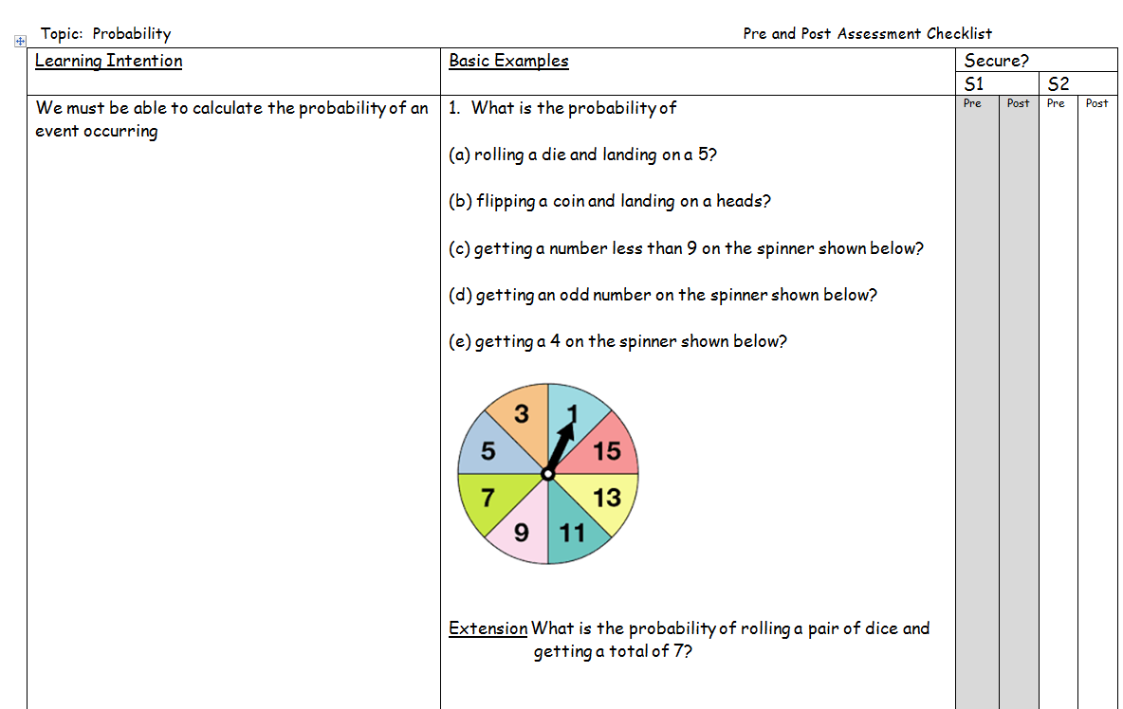
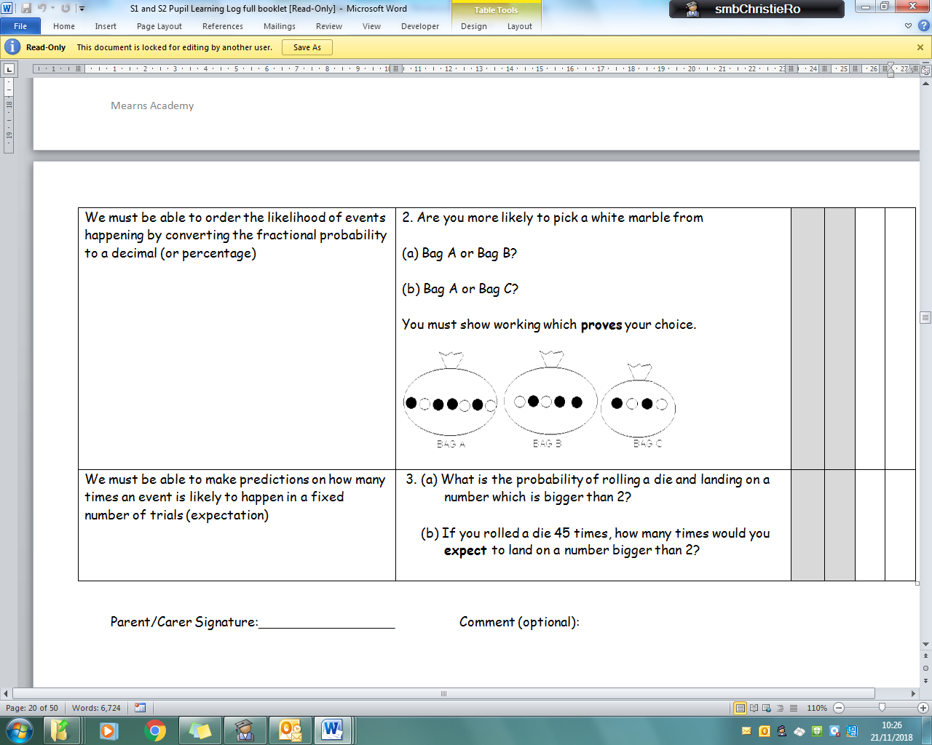

Appendix 3: Senior Phase Self-Assessment Checklists – Advice for Effective Use

REVISION TIPS

- REVISE WORK AT REGULAR INTERVALS

- TRY ‘TRAFFIC LIGHTS’ TO RECORD YOUR PROGRESS

- EVERY SKILL REQUIRED FOR THE EXAM IS MARKED CLEARLY IN YOUR NOTES WITH THE PHRASE,
We must be able to …

- USE ONE OF THE FOLLOWING SYMBOLS BESIDE EACH OF THESE SKILLS

READY FOR EXAM
THIS IS WHERE YOU SHOULD BE BEFORE THE PRELIM AND MUST BE BEFORE MAY
SERIOUS PROBLEMS
- Seek immediate help
- Refer to notes
- Try examples
- Persevere!
GETTING THERE
BUT STILL NOT SURE
- Seek help
- Discuss
- Refer to notes
- Try more examples
- Past Papers with notes
- Persevere!
GAINING
CONFIDENCE
- Continue revisiting notes
- Keep trying examples
- Keep practising past papers
- Persevere!
INSTANT RECALL
SUCCESS IN PAST
PAPERS WITHOUT
REFERENCE TO
NOTES
ROUGHLY
1 MINUTE
PER MARK

