rotary
youth
leadership
awards
2020
Information Leaflet

Girls Camp: 4th July – 11th July 2020
Boys Camp: 11th July – 18th July 2020

What is RYLA about?
The object of RYLA is to develop leadership qualities and team working: to give a sense of pride in achievement; to stimulate mind and body, and in doing so to emphasise the importance of sportsmanship, fitness, character and personal relationships as part of quality living.

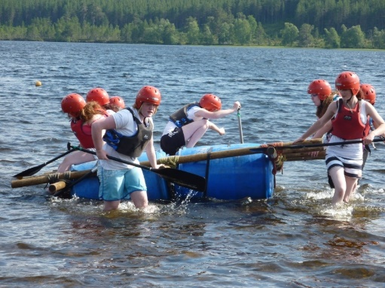
Successful candidates, in the age range 16 -18yo, will participate in a programme of physical and intellectual activities, which will develop skills in:
- Team working
- Positive leadership
- Communication
- Problem Solving
- Decision making

RYLA is operated through your local Rotary club, and participants are chosen who demonstrate leadership qualities which the panel think could be developed by attending the RYLA camp and being exposed to situations which would allow them to demonstrate these qualities. If you are successful and come prepared to put your best into all you do during your stay, there is no doubt that, and the end of the week you will have enjoyed the experience of a lifetime.

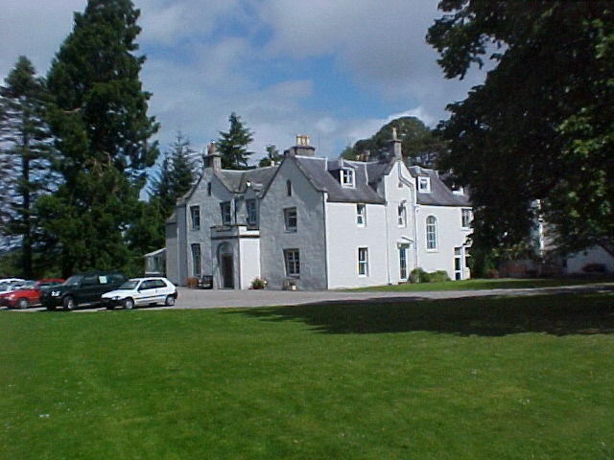
Where does RYLA take place?
Participants travel to Abernethy Outdoor Centre at Nethybridge, near Aviemore, for a week of intensive activities, which are designed to challenge the candidates both physically and mentally.

What is involved?
Participants are divided into groups, usually eight per group with a mentor to look after their welfare. The groups compete against each other in all the various activities with leadership and teamwork being the main objectives.
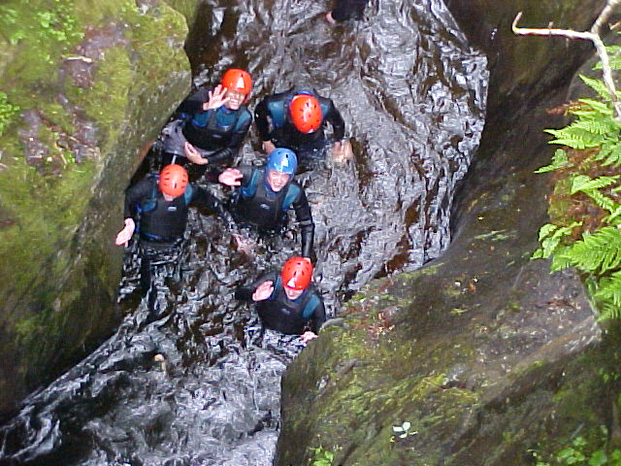
Each of the candidates is given the opportunity to act as the leader of the group during the week.

Activities cover such things as Canoeing, Hill Walking and Map Reading, Mountain Bike Cross Country Riding, Rock Climbing and Gorge Walking

The Abernethy Challenge gives intricate, mind stretching problems to solve, and is an area which highlights leadership potential.

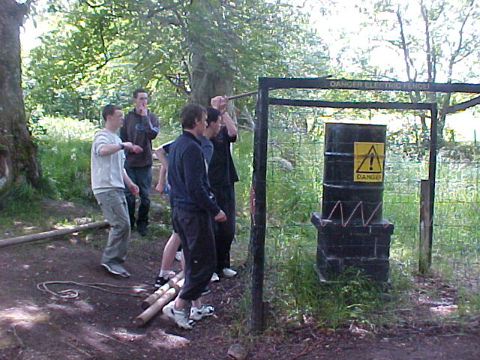
All these activities are controlled and supervised by the staff of Abernethy Outdoor Centre who are all fully qualified.

The intellectual aspect includes team task exercises, evening presentations and discussions on leadership.

At the end of the week each successful candidate receives a Rotary Youth Leadership Award certificate. This is will be presented after you give a short talk on your RYLA experience to your sponsor Rotary Club after you have attended the RYLA camp.

Cost to you and Rotary?
Apart from your need to take a small amount of spending money (the Centre has a small shop for extras), all other costs are met by your sponsoring club including transport to and from the Centre.

If you require any further information on RYLA please contact your local Rotary Club, by the end of December 2019:

Club: LAURENCEKIRK AND DISTRICT
Name: ALBERT DONALD

Telephone No: 07526 574916

Email: albertdoanld5@aol.com

rotary
youth
leadership
awards

