An outline of what your School Careers Adviser will be focusing on in the year ahead

**October**

**UCAS applications**: - need help with a personal statement? - <https://www.myworldofwork.co.uk/learn-and-train/tutorial-writing-personal-statement-ucas-or-college-application>



S1 open evening

P7 Parents’ Information evening

Individual careers appointments with Senior Phase pupils

**September**

**UCAS applications open**

**Higher Education Convention**- chance for pupils and parents to speak to university staff about courses, entry requirements etc.



**S4**: SDS Group work in PSE classes looking at routes and pathways to different careers

Individual careers appointments with Senior Phase pupils

**July**

Assembly talk to new **S6** in preparation for Summer and final year career choices

Holidays!

VOLUNTEER/ FIND A SUMMER JOB!

Parents! You can prepare for #examresults day too with some tips from @mywowscotland <http://ow.ly/RH1230e6iqP>

**August**

**Exam results**

SDS’ Exam Results Helpline opens on results day on **0808 100 8000**. Careers Advisers will be there to discuss what’s right for you.

Didn’t get the #examresults you hoped for? Don’t panic. Visit @mywowscotland for career advice <http://ow.ly/1iTt302BZKS>

Whatever your #examresults, @mywowscotland can help you prepare for your next steps <http://ow.ly/1iTt302BZKS>

Individual careers appointments with Senior Phase pupils

**June**

Start of new academic year -Timetable changes

**P7/S1** introduction to SDS school careers service on transition days

Do you have a C.V. for a summer job? Try the MyWoW C.V. builder at: <https://www.myworldofwork.co.uk/getting-job/building-cv>

**December**

**4th -17th December: Prelims**

**UCAS applications deadline – 13th December**

S2 Parents Evening – 10th December

**S3**: SDS group work in PSE class looking at subject choice

1:1 for all **S3** pupils with a careers advisor to discuss their subject choices

Individual careers appointments with Senior Phase pupils

**February**

**Thinking about an APPRENTICESHIP**? Visit: [www.apprenticeships.scot](http://www.apprenticeships.scot)

There’s still time to put in a college application…

S5/6 Senior Phase Parents’ evening 28th January

**S4 – S6** College application workshop

Individual careers appointments with Senior Phase pupils

S3 Parents Evening 20th February

S4 into 5 Subject Choice deadline 21st February

S5 into 6 Subject Choice deadline 28th February

**January**

Start thinking about **SUBJECT CHOICES:** <https://www.myworldofwork.co.uk/choosing-my-subjects-0>

**DUNDEE & ANGUS** college applications open <https://dundeeandangus.ac.uk/>



Individual careers appointments with Senior Phase pupils

S4 Parents Evening

S4 Work Experience Week 20-24th January

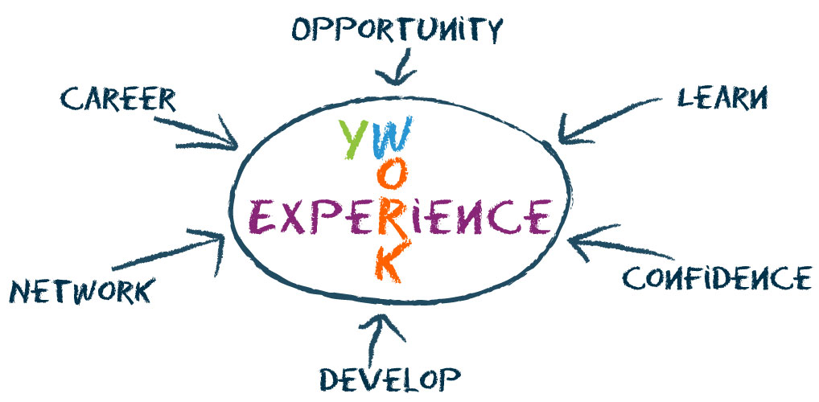

S4 Guidance Interviews

**November**

**NESCoL College** applications open - <https://nescol.ac.uk/>



**S3–S5 Subject Choices**: [myworldofwork.co.uk/parents](https://www.myworldofwork.co.uk/parents) for advice on how to help your child with career choices

Individual careers appointments with Senior Phase pupils

**March**

**Plan ahead**

If you are leaving school in summer– do you have a Plan A and a Plan B sorted?

Parents/Carers! Help your child get the career they want. Visit @mywowscotland for advice. <http://ow.ly/EWDZ302Cs3r>

Individual careers appointments with Senior Phase pupils

Introduction to Work Coach: support available **Post-School**

**School Careers Advisors:**

Angus Hutcheon

**Post-School Work Coach:**

Pam Larson

**May**

**SQA Exams**

**S2**: SDS group work in PSE class focusing on decision making and careers

Individual careers appointments with Senior Phase pupils

**April**

Interview help for college/University

<https://www.myworldofwork.co.uk/nail-your-college-interview>

Individual careers appointments with Senior Phase pupils